Progetto per il corso di Metodi Quantitativi Per L’Informatica: Confronto tra le reti Darknet Yolo e Faster-RCNN

Facoltà di Ingegneria dell’Informazione, Informatica e Statistica
Dipartimento di Ingegneria Informatica, Automatica e Gestionale “Antonio Ruberti”
Corso di laurea in Ingegneria Informatica e Automatica

Marco Costa
Matricola 1691388

A/A 2017/2018
PURPOSE
The project consists in a comparison between two different types of Neural Networks on image detection. Both the networks are pre-trained on Pascal VOC 2007 Train/Val set and runs on the same hardware. They can identify 20 different categories: (Aeroplane, Bicycle, Bird, Boat, Bottle, Bus, Car, Cat, Chair, Cow, Dinning table, Dog, Horse, Motorbike, People, Potted plant, Sheep, Sofa, Train, TV/Monitor).
They will be tested on the Pascal VOC 2007 Test set (first 1000 images) and Coco 2017 Test set (first 1000 images).
HARDWARE SPECIFICATIONS
CPU: Intel Core i7-4720HQ (2.60-3.60 GHz, 6MB Cache
GPU: Nvidia GeForce GTX 950M (4096MB DDR3)
RAM: 16 GB (DDR3L 1600 MHz SDRAM)
STORAGE: SSD 525 GB + HDD 1000 GB
FEATURES
Darknet YOLO
YOLO (You Only Look Once) is a real-time object detection system that uses neural networks to detect objects in images. It is written in C.
How it works:
It applies a single neural network to the full image. This network divides the image into regions and predicts bounding boxes and probabilities for each region. These bounding boxes are weighted by the predicted probabilities.
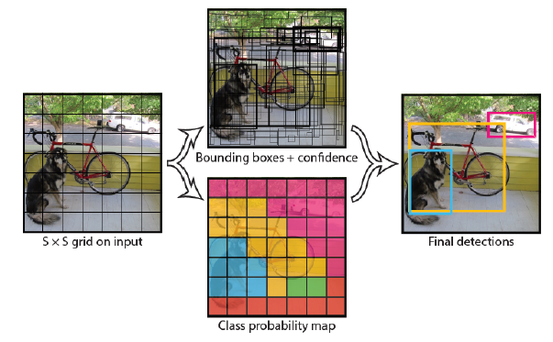
Advantages:
- It looks at the whole image at test time so its predictions are informed by global context in the image;
- It also makes predictions with a single network evaluation unlike systems like R-CNN which require thousands for a single image;
- This makes it extremely fast, more than 1000x faster than R-CNN and 100x faster than Fast R-CNN.
Architecture:
YOLO detection network has 24 convolutional layers, followed by 2 fully connected layers. It alternates 1 x 1 convolutional layers to reduce the features space from the preceding layers. Initial convolutional layers extract features from the image and the fully-connected layers predict the output probabilities and coordinates of the object.
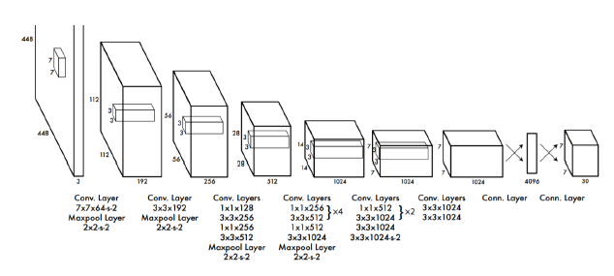
Faster-RCNN
How it works:
Faster R-CNN has two networks: region proposal network (RPN) for generating region proposals and a network using these proposals to detect objects.
Some operations execute on the CPU in Python layers.
RPN ranks region boxes (called anchors) and proposes the ones most likely containing objects.
Architecture:
The input images are represented as Height×Width×Depth tensors (multidimensional arrays), which are passed through a pre-trained CNN up until an intermediate layer, ending up with a convolutional feature map.
Next, there is a Region Proposal Network (RPN). Using the features that the CNN computed, it is used to find up to a predefined number of regions (bounding boxes), which may contain objects.
After having a list of possible relevant objects and their locations in the original image, it becomes a more straightforward problem to solve. Using the features extracted by the CNN and the bounding boxes with relevant objects, there is a Region of Interest (RoI) Pooling and it extracts those features which would correspond to the relevant objects into a new tensor.
Finally, comes the R-CNN module, which uses that information to classify the content in the bounding box (or discard it, using “background” as a label) and adjust the bounding box coordinates (so it better fits the object).
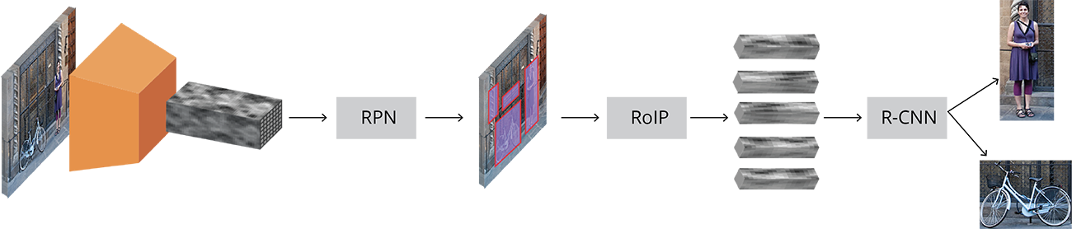
EXPERIMENT
Detection Treshold:
Since the output detections of our model are the probabilities of a detection being reliable, we can establish a threshold to discard predictions with low probability. This way we can adjust the level of reliability of our model and decide weather to be more or less restrictive.

CONCLUSIONS

REFERENCES
- Darknet Yolo - YOLO: Real-Time Object Detection (https://pjreddie.com/darknet/yolo)
- Faster-RCNN - ZF model (https://github.com/rbgirshick/py-faster-rcnn)

